## Tests Conducted

|  |  |  |
| --- | --- | --- |
| Test | Expected Result | Result |
| Pressed Right Arrow to iterate through the profiles | Records stop at final record and does not throw “out of range” exception | Records stop at final record and does not throw “out of range” exception |
| Pressed Left Arrow after previous test | Records stop at first record and does not throw “out of range” exception | Records stop at first record and does not throw “out of range” exception |
| Iterated through the profiles and ensure all profile names are output correctly | The profile names do not contain any incorrect or additional data. | Profile names read as expected, no additional characters. |

## Keyboard Shortcuts

Run: F5  
Stop: Shift + F5  
Restart: Ctrl + Shift + F5

Step Into: F11  
Step Over: F10  
Step Out: Shift + F11

# Screenshots

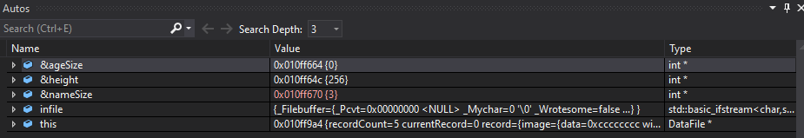  
Auto watched variables

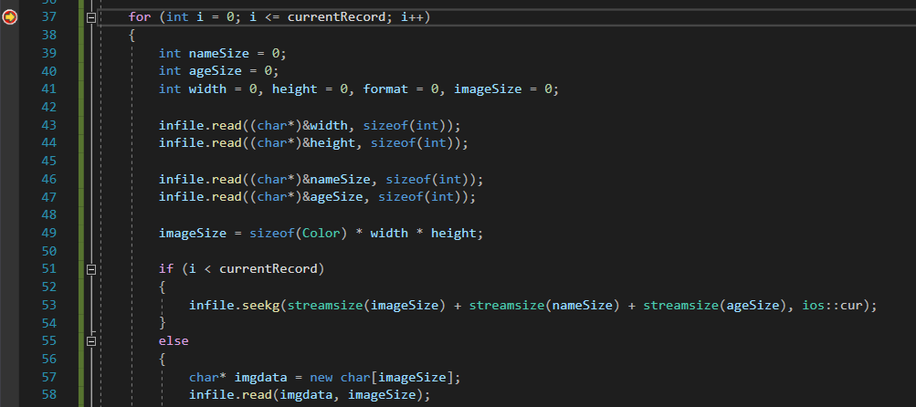  
Breakpoint Usage

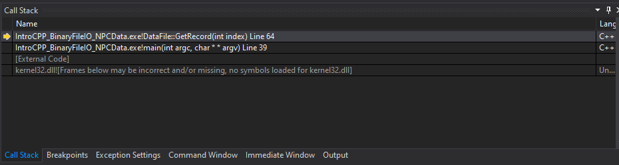  
Callstack

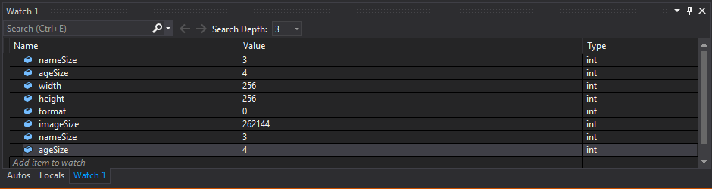Custom watched variables